**Excel Assignment - 7**

1. Using Insert Function, give examples of any function available in the different dropdowns present in the function library. For example AutoSum, Recently Used, Text, Date & Time, etc

Use the**Insert Function** dialog box to help you insert the correct formula and arguments for your needs. (To view the **Insert Function** dialog box, click Insert function

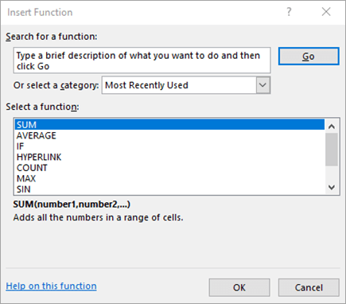

1. **What are the different ways you can select columns and rows**
2. Select the letter at the top to select the entire column. Or click on any cell in the column and then press Ctrl + Space.
3. Select the row number to select the entire row. ...
4. To select non-adjacent rows or columns, hold Ctrl and select the row or column numbers.

**3. What is AutoFit and why do we use it?**

AutoFit is a feature in Excel that **allows you to quickly adjust the row height or column width to fit the text completely** (so that there is no spilling over to .

**4. How can you insert new rows and columns into the existing table?**

Add a row above or below

1. Click in a cell above or below where you want to add a row.
2. Under **Table Tools**, on the **Layout** tab, do one of the following:
   * To add a row above the cell, click **Insert Above** in the **Rows and Columns** group.
   * To add a row below the cell, click **Insert Below** in the **Rows and Columns** group.

**5.How do you hide and unhide columns in excel**

**Hide or show rows or columns**

1. Select one or more columns, and then press Ctrl to select additional columns that aren't adjacent.
2. Right-click the selected columns, and then select Hide.
3. **Create an appropriate table within the worksheet and use different functions available in the AutoSum command.**

If you need to sum a column or row of numbers, let Excel do the math for you. Select a cell next to the numbers you want to sum, click AutoSum on the Home tab, press Enter, and you're done. When you click AutoSum, Excel automatically enters a formula (that uses the SUM function) to sum the numbers.